Discord Bot

This is a Discord bot created using Python and the Discord.py library.

Getting Started

Creating a Discord Bot

To create a Discord bot, you will need to have a Discord account and be logged in. Then, follow these steps:

Go to the Discord Developer Portal.

Click the "New Application" button and give your application a name.

Click on the "Bot" tab in the left menu, and then click the "Add Bot" button.

Give your bot a name and upload an avatar if desired.

Click the "Copy" button under "Token" to copy your bot token to your clipboard.

Setting up the Bot Program

when setting up your bot set these permissions:

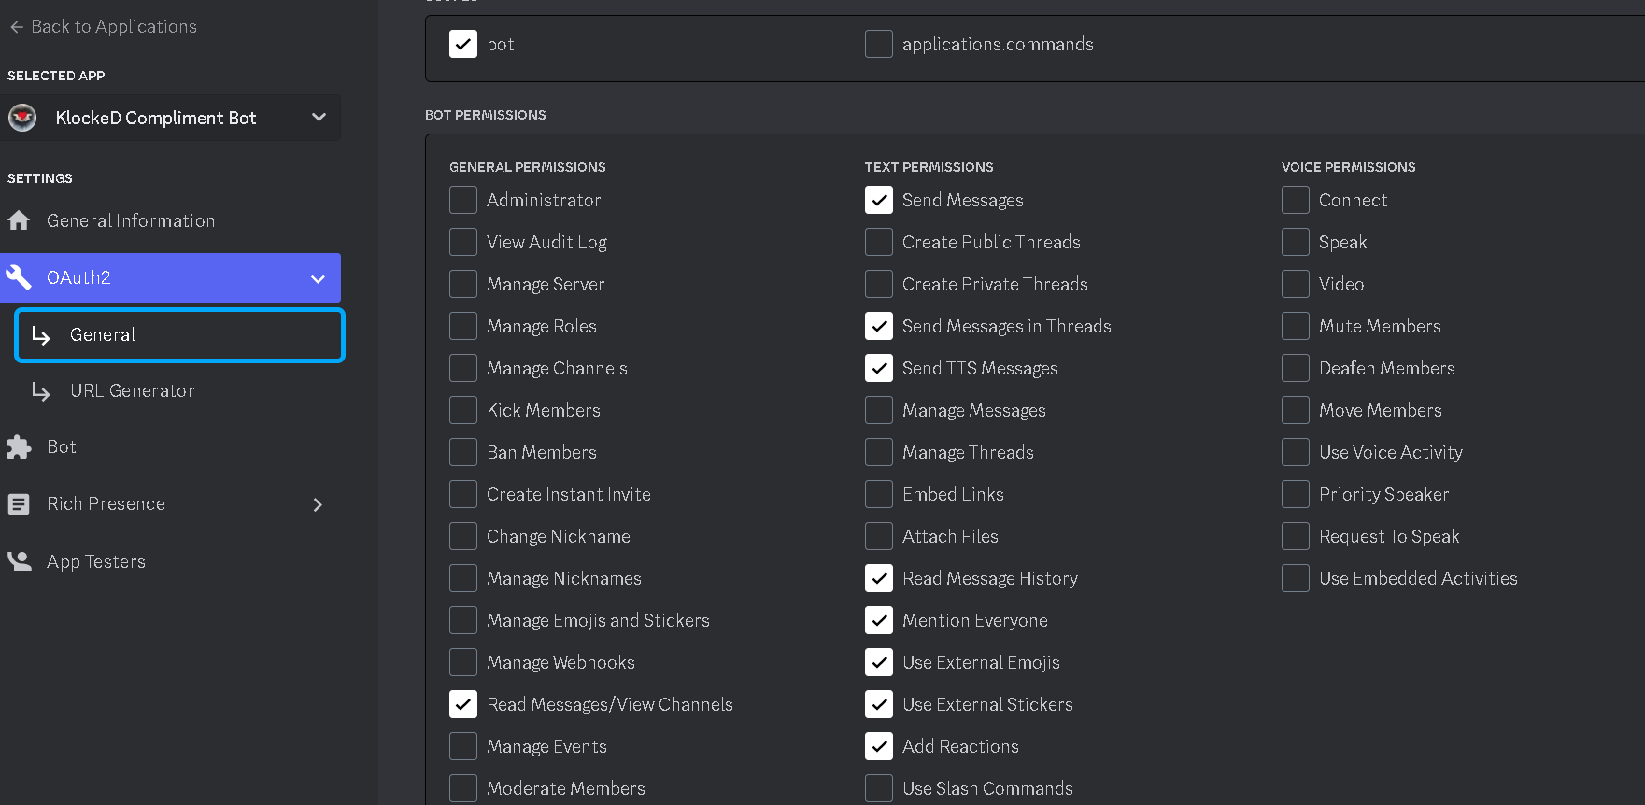

Goto URL Generator and select the exact same permissions:

Scope is bot:

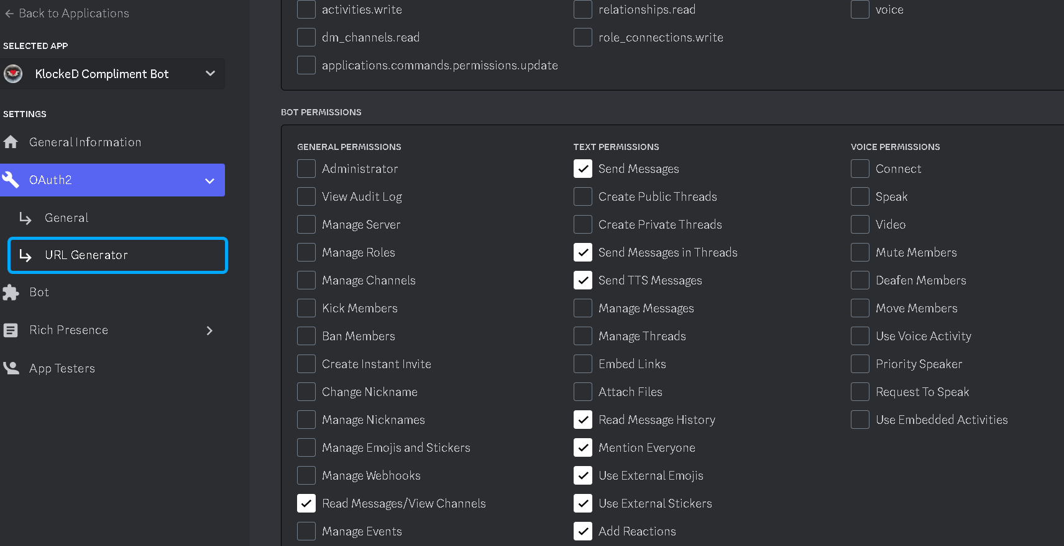

Once you do that it will generate a URL for your bot so you can invite it to your server with the permissions for the bot set correctly.

Goto the Oauth2 tab on the left side of the screen of your bot application and paste the URLin the redirects section.



Goto the Bot tab:

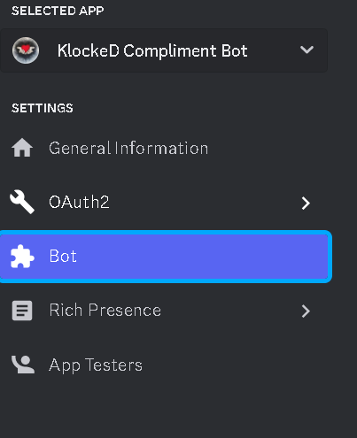

Make sure permissions are set correctly:

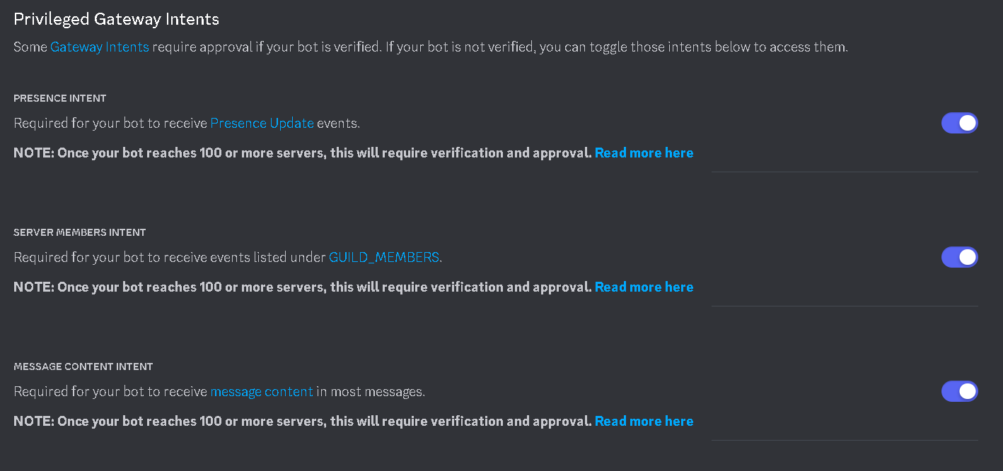

**You will find your bot token also in this tab.**

To set up the bot program on your machine, follow these steps:

Clone or download the repository to your local machine.

Create a file named .env in the root directory of the repository.

Open the .env file in a text editor and paste your bot token into the file like this:

BOT_TOKEN=<your bot token here>

Save the file and close the text editor. The file should just be named .env nothing before the period. So just .env

You can also just create a new text file, and paste BOT_TOKEN=<your bot token here> into the text file. Then close the text file and rename it to .env make sure not to put anything before the .env you will just rename it to .env thats it. Also make sure to replace <your bot token here> with your actual bot token.

Running the Bot Program

To run the bot program on your machine, open a terminal or command prompt and navigate to the root directory of the repository. Then, run the following command:

Klockedcomplimentbot.py

The bot should now be running and ready to respond to commands in your Discord server.

You can also just download Python IDLE, copy and paste the code into IDLE, and hit Run Module. It will open up a terminal and run the code for discord.

Commands

The following commands are available for use with this bot:

!c <@member>: Compliments the specified member by mentioning them with a random compliment.

You can also type !c partial name, or full name and the bot will target the person in the discord chat with the partial name you’ve given.

Acknowledgments

This bot was created using the Discord.py library. - KlockeD